

ASKLEADERS

[Document subtitle]



[Date]

CtrlSoft

[Company address]

**ASKLEADERS**

**A PROJECT REPORT**

***Submitted by***

Mahirali Chaudhari

Saurabh Yadav

***In fulfillment for the award of the degree***

***Of***

**BACHELOR OF ENGINEERING**

***In***

Computer Engineering



Government Engineering College, Bhavnagar

CERTIFICATE

**Gujarat Technological University, Ahmedabad**



This is to certify that **Mahirali Chaudhari** of B.E 8th semester, COMPUTER Engineering department, Enrollment no. **130210107005** has satisfactorily completed her term work of Project-II during the academic year 2016-17.

_______________ ________________

**Staff In-Charge Head of Department**

CERTIFICATE

**Gujarat Technological University, Ahmedabad**



This is to certify that **Saurabh Yadav** of B.E 8th semester, COMPUTER Engineering department, Enrollment no. **130210107049** has satisfactorily completed her term work of Project-II during the academic year 2016-17.

## _______________ ________________

**Staff In-Charge Head of Department**

**ACKNOWLEDGEMENT**

I take this opportunity to express my profound gratitude and deep regards to my guide **Mr Nishant Makwana** from, Government Engineering Collage, Bhavnagar for her exemplary guidance, monitoring and constant encouragement throughout the project development. The blessing, help and guidance given by her time to time shall carry us a long way in the journey of life on which we are about to embark.

Last but not the least, our appreciable also goes to all staff members of Computer Engineering Department and to our fellow classmates who directly or indirectly helped us.

Finally our deepest gratitude goes to our parents who have given us much needed comfort, support, encouragement and inspiration for completing this project.

Date:

Mahirali Chaudhari (120210107026)

Saurabh Yadav (120210107027)

**CHAPTER 1**

**INTRODUCTION**

* 1. **PROBLEM SUMMARY :-**
* The basis of this project is to provide a better co-ordination between the employees of an organisation, their leader’s and students of any institution with their respected teacher’s or principal.
* It will help both the leader/principal and employees/students to interact in a better and efficient way.
* It will help to share information at a faster speed.
* Any user can share the information, can follow current topics related to nation or any other.
* Results and other notices can be broadcast online instead of publishing on the notice boards/hoardings etc.
* Users can get fast access to results/information and need not to stand in the queue.
  1. **Aim and objectives of the project**
* It will a provide platform to ask questions to industry leader/experts.
* The users can get to the point answer from their leaders.
* Users can follow other leader’s and can learn from them.
* Registered user can follow topics.
* Registered user can see the work portfolio of leaders
* Leader’s can create poll about any topic.
* Register user can give their opinion about the same
  1. **Problem Specifications**

The problem that we intend to solve using this android application is to reduce the gap between the different levels of any organisation. We want to provide a platform that will enable the leader’s or employees of an organisation in a better way.

Using this application leader’s can share their views with employees. They can motivate their employees to work better and increase their performance. And, the employees can also directly ask questions to their respective leader and get the solution of their queries.

Hence, we want to erase the communication gap that exists between employees and leader’s. Project can further be used for broadcasting information. Results can also be broadcast on this application .

* 1. **Brief literature review**

As we know the social media is on the ninth cloud and everyone is using it. Hence, we have gone through number of social media applications before selecting this project. After the web search we decided to make this application which is social but only for professional purpose. Also, we have gone through a number of patents to decide different modules of our application or to decide the different that activities that the user can perform on our application.

One of the patent was about opinion poll and we decided to include it in our application. The brief summary of the patent is given below:

US. PATENT DOCUMENTS

A system to conduct a public-initiated opinion poll on a media space or in a consumer space. Simple activation of software or hardware-based buttons or otherwise by speaking into or tapping on a device are provided and enables the public to express its likes/dislikes about anything, anyone, anywhere, anytime and merely when he/ she decides to do so. Hence, this system replaces the current survey-based paradigm in which the surveyor decides when to ask what, and how from the public.

* 1. **Plan of their work :-**
* Register for appropriate account type
* Authentication
* Notification Service
* If Leader
  + Create work_portfolio
  + Generate opinion poll
  + Answers questions
  + Share opinion/views
* If any other user
  + Create work_portfolio
  + Asks questions
  + Take part in opinion poll
  + Share views/opinion
  + Follow leaders
* If Admin
  + Manages Database
  + City Management

**1.6 Technology Used**

* MySQL for server side database.
* SQLite for android app database.
* Django for development of web services (Python for coding ).
* Java and xml for app designing.

**1.6.1 Hardware-Software used**

* Hardware Requirement
  + CPU : Intel core i3 ,2.5-3.1 Ghz recommended
  + Memory (RAM): 4 or 6 GB RAM recommended
* **Software Requirement**
* Android studio (**Android Studio** is the official integrated development environment (IDE) for Android platform development.)
* Mysql (**MySQL** is an open-source relational database management system (RDBMS). It is used to create server side database.)
* Wamp Server(**WampServer** refers to a software stack for the Microsoft Windows operating system, created by Romain Bourdon and consisting of the Apache web server, OpenSSL for SSL support, Mysql database and php programming language.)
* Python 2.5(**Python** is a widely used high-level, general-purpose, interpreted, dynamic programming language. Its design philosophy emphasizes code readability, and its syntax allows programmers to express concepts in fewer lines of code than possible in languages such as C++ or Java.)
* Genymotion ( It is the best android emulator for app testing and presentation.)

**1.6.2 SYSTEM REQUIREMENT:-**

* **Windows :**
* Microsoft® Windows® 8/7/Vista/2003 (32 or 64-bit)
* 2 GB RAM minimum, 4 GB RAM recommended
* 400 MB hard disk space. At least 1 GB for Android SDK, emulator system images, and caches
* 1280 x 800 minimum screen resolution
* Java Development Kit (JDK) 7
* Optional for accelerated emulator: Intel® processor with support for Intel® VT-x, Intel® EM64T (Intel® 64), and Execute Disable (XD) Bit functionality
* **Linux**
* GNOME or KDE desktop
* GNU C Library (glibc) 2.15 or later
* 2 GB RAM minimum, 4 GB RAM recommended
* 400 MB hard disk space. At least 1 GB for Android SDK, emulator system images, and caches
* 1280 x 800 minimum screen resolution
* Oracle® Java Development Kit (JDK) 7

**Chapter 2**

**Design: Analysis, Design Methodology and Implementation Strategy**

**1.AEIOU Summary**

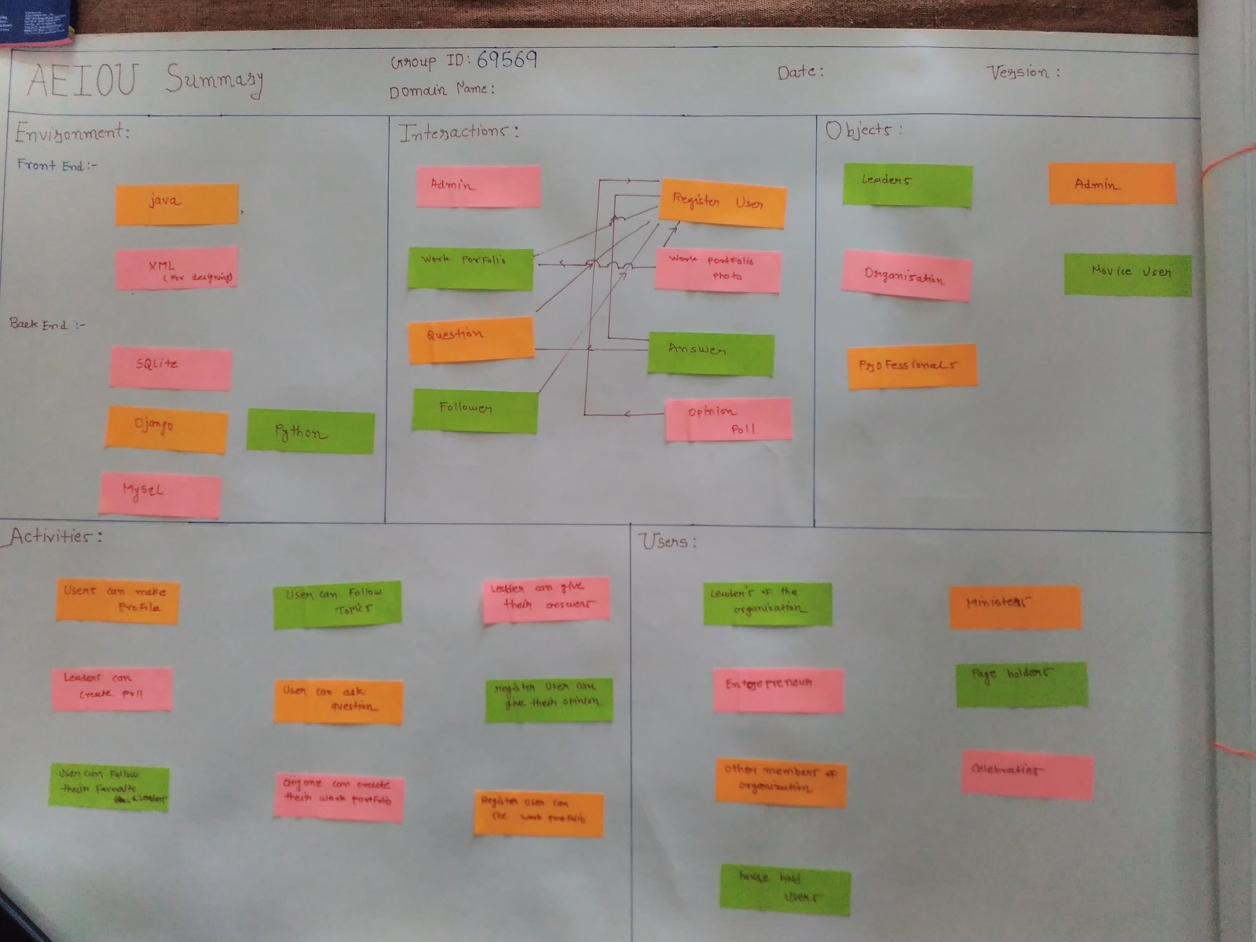

The AEIOU summary is divided into five portions:-

* **Environment :-** 
  + It is to show the technologies that we are going to use to make the front end and back end of the system.
  + Front End :- In the front end we are going to use Java, Xml and android.
  + Back End :- While, in the back end we are going to use MySql, SQLite, Django and Python.

1. **Interaction :-**

* This portion is to show the kind of interaction between the users and the different modules of the application.
* Eg. In our application the register user is able to interact with all the other modules such as opinion poll, question and answers etc.

1. **Activities :-**

* This portion shows the different activities that can performed in our application. The following are the activities that can be performed by registered user on our application:-
* Registered user can ask questions and get to the point answer.
* He can take an opinion poll on any topic.
* He can follow others.
* He can develop his work portfolio.

1. **Users :-**

* This portion shows the different class of users that can use this applications. In this application the following person can use this application:-
* Leader’s of any organisation.
* Employees of any organisation.
* Naïve users
* Household users.

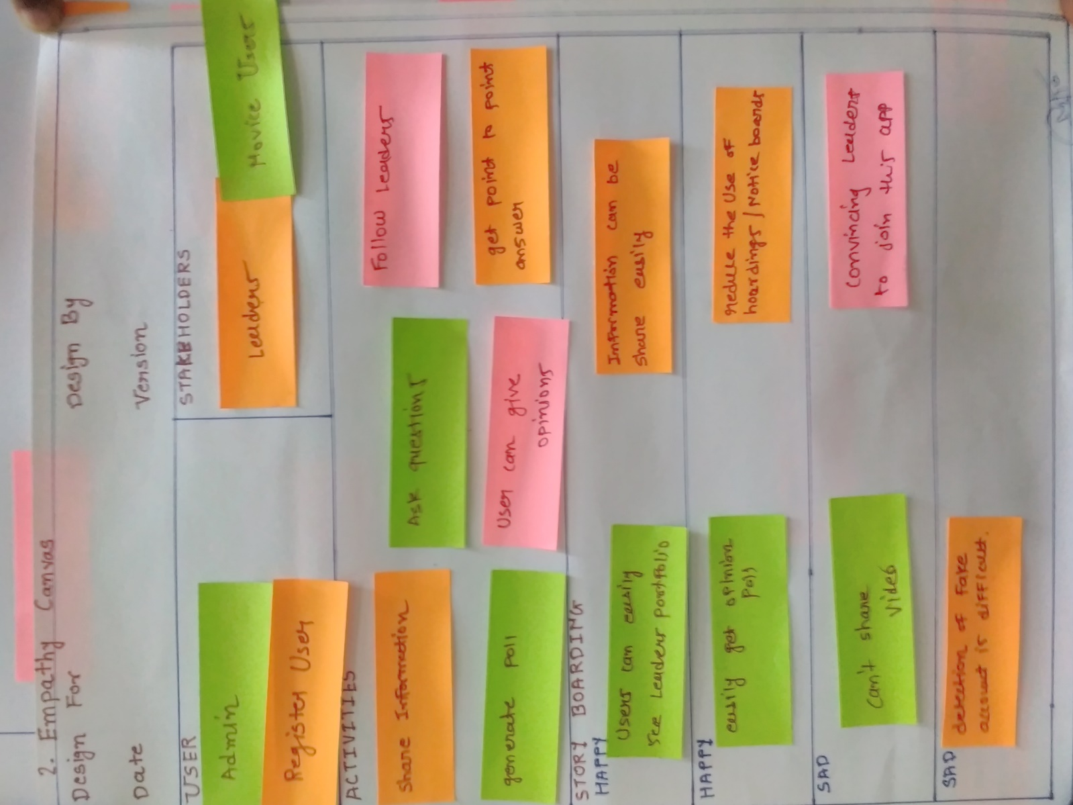 **2.Empathy Canvas**

This canvas consists of four portions:

1. **User :**

* We have two users who can access this application:-
  + - Admin
    - Registered User

1. **Activities :**

* The following are the activities that can be performed:
* Information can be shared.
* Questions can be asked.
* Answers can be given.
* Opinion poll can be generated.
* Users can follow each other.

1. **Story Boarding:-**

* **Happy** :-
* Information can be shared easily.
* Reduces the use of papers for publishing results and notices.
* Opinion poll can be generated on burning topics.
* Leader’s portfolio can be seen by registered user.
* Sad :-
* Video cannot be shared.
* Convincing leader’s and experts to join this app is challenging task.
* Aadhar no. of each user is required to detect the fake accounts.

1. **Stakeholders :-**

* Naïve users
* Leader’s/ experts
* Admin

**3. Ideation Canvas :-**

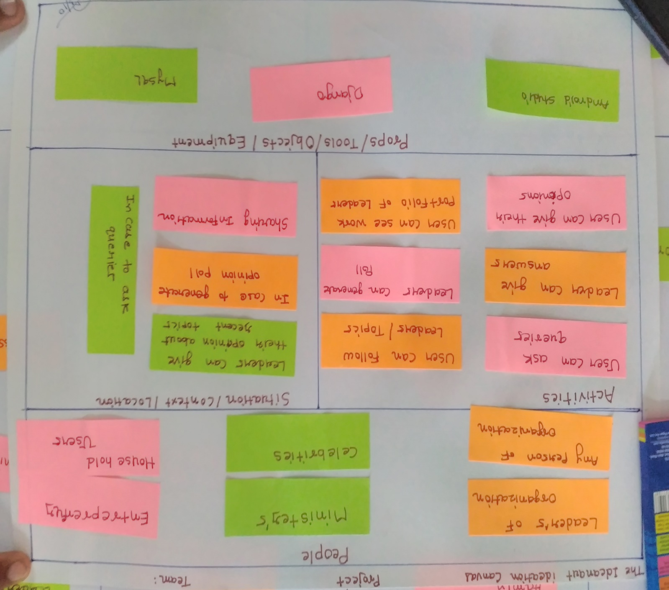

The ideation canvas consists of four prospects that are described below:-

1. **People :-**

* The following are the person associated with this application:
* Admin
* Registered users
* Naïve users
* Leader’s / experts
* Celebrities
* Employees/ Professsionals

1. **Activities :-**

* The following are the activities that can be performed:
* Broadcasting/sharing information.
* Generation of poll can be done.
* Users can follow each other.

1. **Situation/Context :-**

* This portion describes the different situations where this application proves helpful.
  + - In case to know the public opinion for decision making.
    - In case to share information.
    - In case to get the solution of the queries.

1. **Tools/Objects**

* It shows the different tools that will be used for developing the application.
* Android Studio
* Django
* MySql

**4. Product Development Canvas :-**

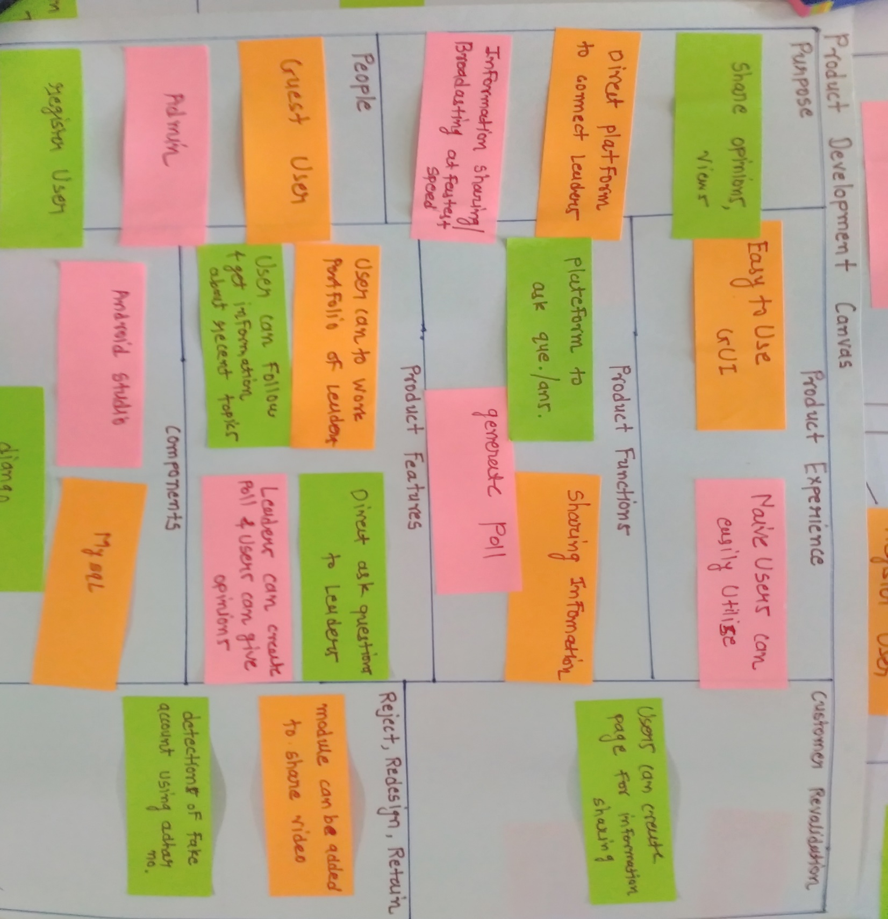

The product development canvas consists of eight portions that are described below :-

1. **Purpose :-**

* It is to show the basic purpose of developing this application.
* Share personal opinion and views.
* Direct platform to connect to leader’s/experts.
* Information sharing/ broadcasting.

1. **Product Experience :-**

* We will provide easy to use GUI.
* Naïve users can easily use this application.

1. **People :-**

* It is to show the people who are going to use this application:-
* Admin
* Registered user
* Leader’s/ Experts
* Naïve users

1. **Components** :-

* The components to be used for the development of this app are:
* Android Studio
* MySql
* Django

1. **Reject, Redesign, Retain :-**

* A module can be later added to share video.
* Fake accounts can be detected using aadhar card.

**3. Implementation**

**3.1 Data Dictionary :-**

**1. Admin**

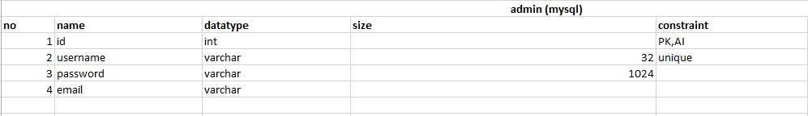

1. **Registered User :-**

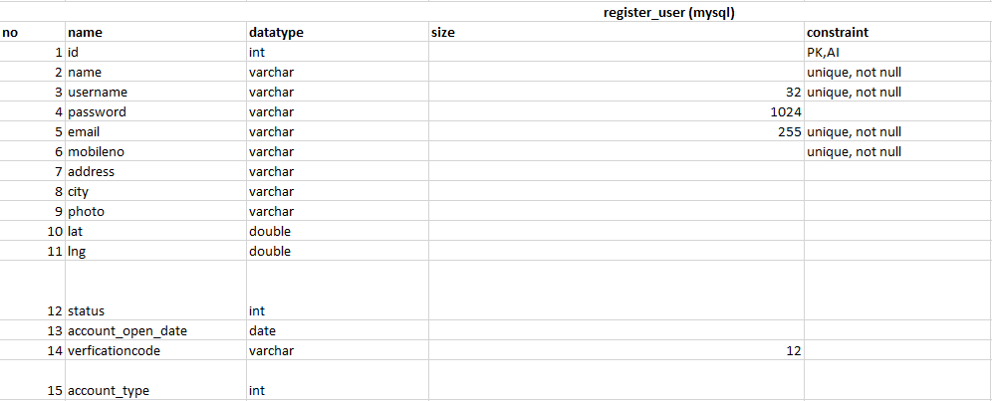

1. **Work_Portfolio :-**

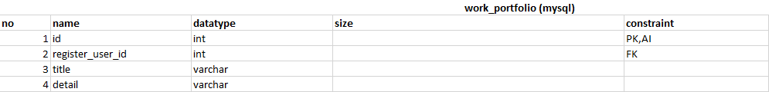

1. **Remarks :-**

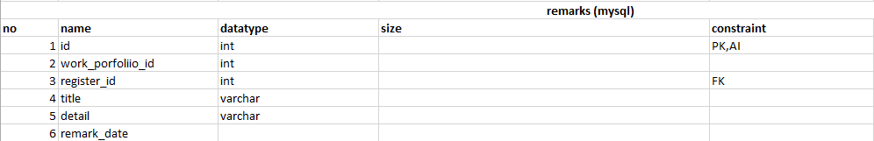

1. **Work_Portfolio_photo :-**

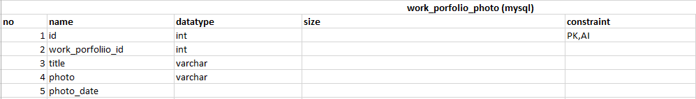

1. **Question**

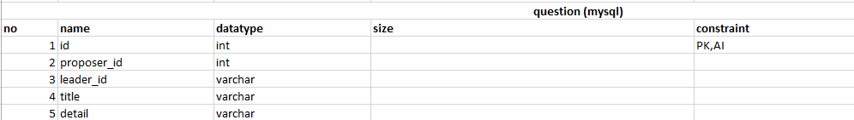

1. **Answer**

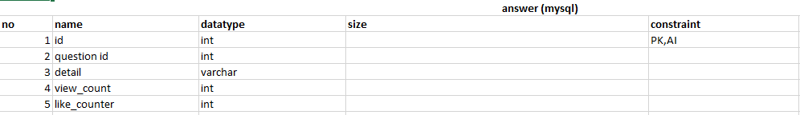

1. **Topic_Category :-**

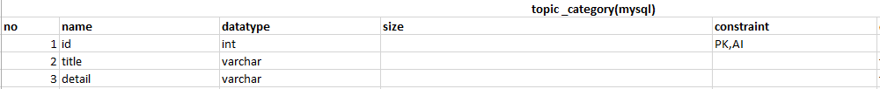

1. **Follower :-**

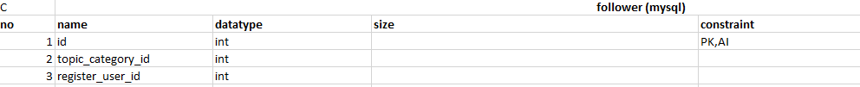

10**. Opinion Poll :-**

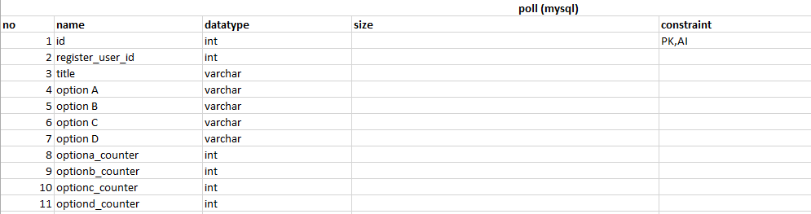

**3.2 DATA FLOW DIAGRAM/ UML DIAGRAM**

**1) Activity Diagram**

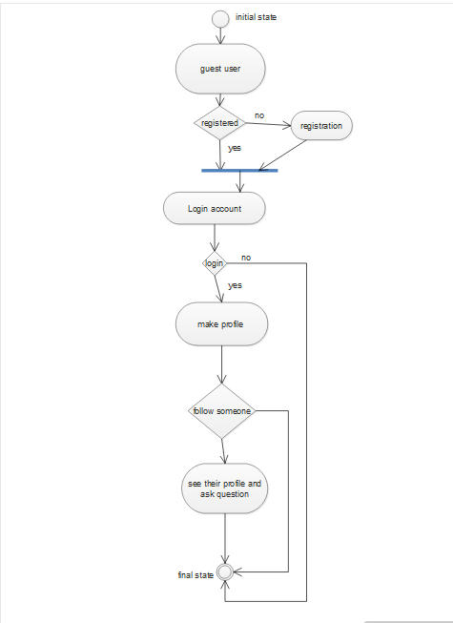

**2) Class Diagram**

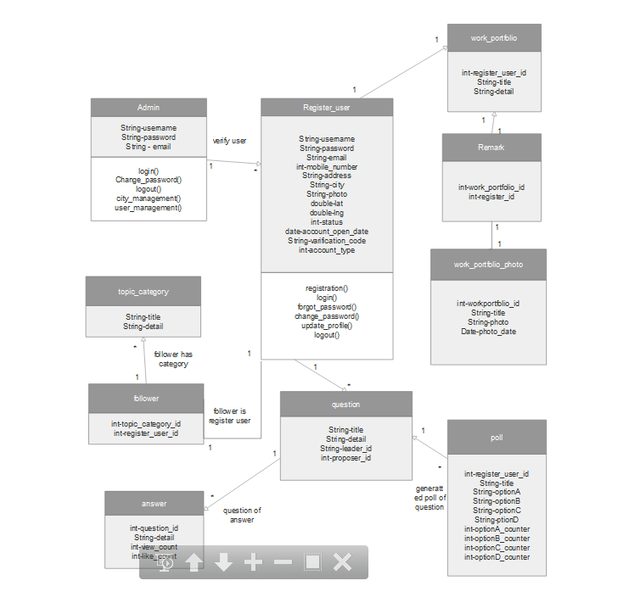

**3) E-R Diagram**

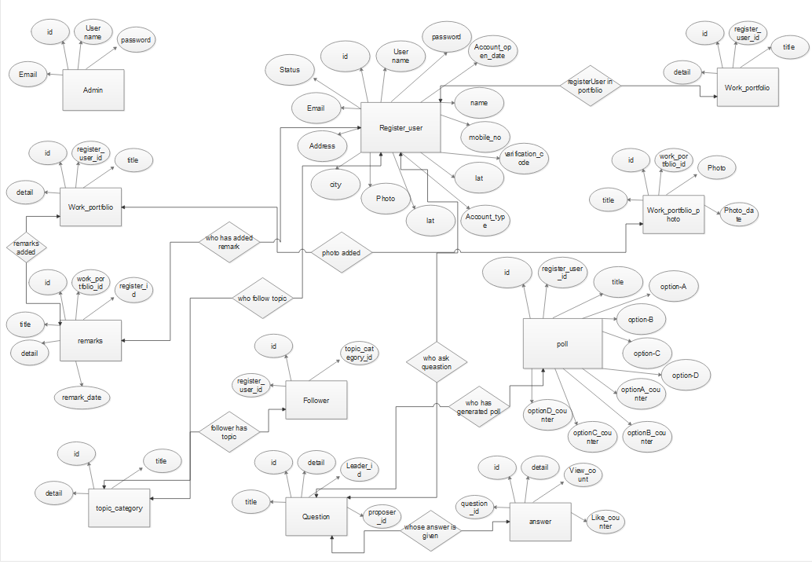

**4) Sequence Diagram**

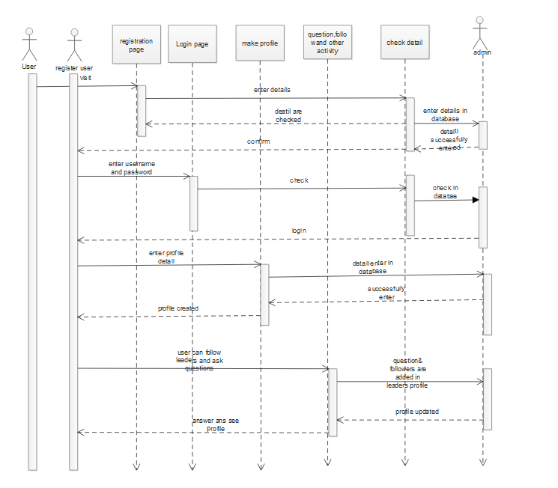

**5) Use-Case Diagram**

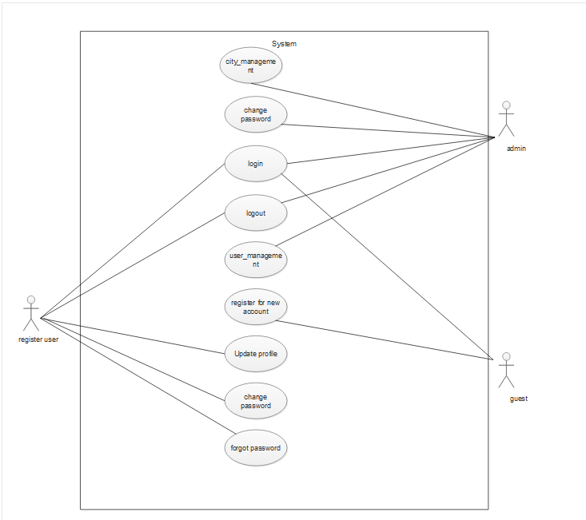

**CHAPTER 4**

* 1. **Summary :-**

The summary of this whole project is to make the life of individual learners or employees of any organisation a bit easy. We aim to link all the people within an organisation in a better way that will result into better performance as a group.

Our aim is to give an equal and accessible opportunity to each and everyone to ask their questions and get to the point answer from experts and leaders. They can also share their opinion, views on the current burning topics. We want everyone to be a part of decision making. Hence, whenever a decision is to be taken on key issues than public can give their opinion and can influence the decision of the government.

Or the other way round, the politicians or leaders can generate the opinion poll and individual users can give their respective opinions to influence the leaders. The labours/employees can also raise their issues regarding salary and the leader’s can handle them easily through this application. It can also be used to display results or public notices and reduces the use of paper and hoardings. And, the students do not need to stand in queue to read their marks or the notice.

* 1. **Advantages or Usefulness of System :-**
  + This application provides platform to ask question to industry leader/experts.
  + User’s can get to the point answer of raised question.
  + User’s can follow their favourite leader.
  + Registered user can follow topics.
  + Registered user can see the work portfolio of leaders.
  + Leader’s can create poll.
  + Registered user can give their opinion about the same.
  + Results/Notice can be broadcast on this application.
  + Users don’t need to stand in the queues to see the marks/notice.
  1. **Scope of Future work :-**
     + A module can be added to share videos.
     + Fake accounts can be detected using the aadhar card. But, we will need the whole aadhar database from the government.
  2. **Benchmarking with Existing product :-**

As we know twitter is an amazing to use. Almost each of us uses the twitter to share our views and opinions. But, twitter is a social application where people share everything while our application is mainly to be used for professional purpose and a bit social.

In our application people will ask questions related to their profession or errors in their code to which solution can be provided by experts. In our application, groups can be made for a particular organisation and all the important information and notices can be shared in the group for fast traversal of information and reducing the communication gap between the people of different level. And, the opinion poll can also be generated on any topic by the leaders to make the decision with the consensus of all.

|  |  |  |
| --- | --- | --- |
| Patent No. | Title | Summary |
| US 8892728 B2 | Automatic zone-based management of a data center | Automatic zone-based management of a data center. Nodes are assigned to a first zone.  One of the nodes is selected as zone leader.  A load ratio of the zone leader is monitored, nodes are identified for shedding if the load ratio exceeds a predetermined maximum,  and the identified nodes are assigned to a new zone. One of the nodes in the new zone is selected as zone leader. The load ratio of each zone leader is monitored, nodes are identified for shedding if the load ratio exceeds a predetermined maximum,  and the identified nodes are assigned to an  additional new zone,the zone leaders negotiate for reassignment of loads. |
| WO 2013050552 A2 | User interfaces for determining the reaction of a group with respect to a set of elements | Method to know the reaction of a group reaction of a group respect to a set of elements and various applications of this model The present invention provides systems and methods that provide knowledge about a reaction (e.g. interest) of a group (normally of people) with respect to a set of elements, wherein each group member can react in a different manner. Assuming that the group is accessible by electronic means (e.g. Internet) this system may be based on a group response algorithm to estimate group reaction minimizing workload of group members and minimizing the time needed. To minimize or reduce group members' workload and time, the algorithm uses statistic tools.The group response system estimates group reaction with previously set statistic reliability.  The present invention can use too in some cases, secondary algorithms for specific cases. |
| WO 2014108678 A1 | Improved information sharing | Systems and methods for the sharing of information between organizations are disclosed. Policies that govern the permissions for the sharing of information are represented as Boolean functions such as Binary Decision Diagrams. |
| US7478054B1 | Sharing information about purchases | A facility for notifying a first user about a purchase made by a second user is described.The facility detects that the second user has purchased an item. The facility further determines that the first user has a purchase notification relationship with the second user.  The facility then provides to the first user an notification that the second user has purchased the item. |
| US20120046936A1 | System and method for distributed audience feedback on semantic analysis of media content | A system and computer implemented method of distributed audience feedback of media content in real time or substantially real time,  including: semantically analyzing, at a semantic speech analysis engine,  media content from a media program and identifying relevant topic data; distributing, at a topic data publisher, the identified relevant topic data to an audience of the media program; collecting, at a server, audience opinions on the identified relevant topic data;  and processing the collected audience opinions. Other embodiments are disclosed. |

